# About My Workspace

My Workspace screen helps the user to filter, view, open, perform, review, update, and approve records.

My Workspace is where the users will do the following:

* Filter, view and perform compliance
* Create and manage tasks and sub tasks
* Filter, view, and process licenses
* Filter, view and process checklist

1. On the main menu, click My Workspace and then click Compliance / License / Checklist. The My Workspace screen appears as shown in the figure:

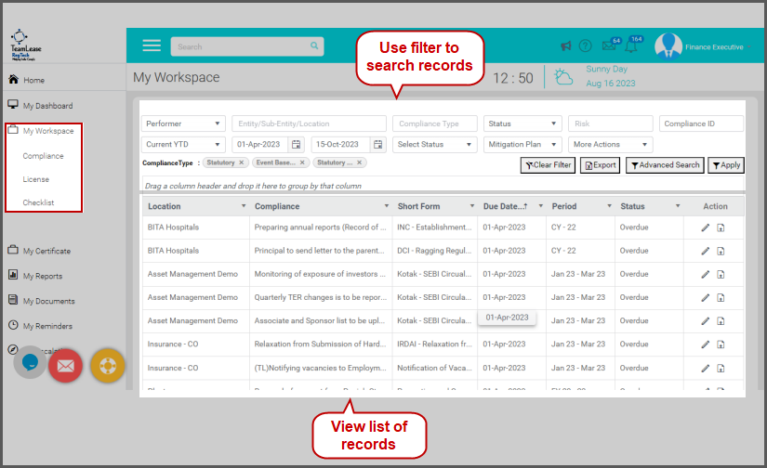

Here you can filter, view and perform the compliances / licenses /checklist records.

## Using Filter Options

My Workspace enables the user to filter records based on the following options:

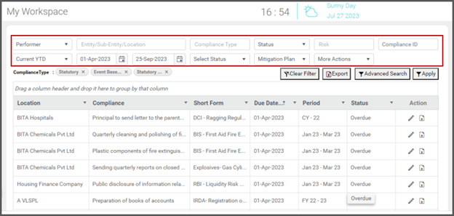

### 

### Entity/Sub-Entity/Location

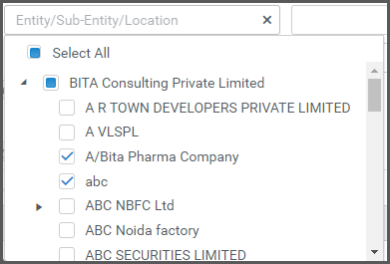You can filter records based on Entity/Sub-Entity/Location as shown in the figure:

1. Click on the Entity/Sub-Entity/Location field. The tree view of the locations assigned to you appears. Click to select the locations.
2. To select all locations, click Select All option.
3. Click Apply. Records matching the selected locations are listed.

### Compliance Type

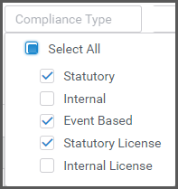Filtering Records Based on Compliance Type

You can filter records based on Compliance Type as shown in the figure:

1. Click on the Compliance Type field. List of compliance types appears.
2. Click to select the compliance type to filter records. You can select multiple types to filter.
3. To select all the types, click Select All.
4. Click Apply. Records matching the selected compliance type appears.

### Status

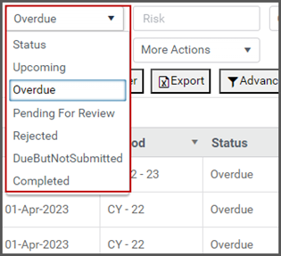You can filter records based on compliance status as shown in the figure:

1. Click on the Status field. List of following statuses appears:
   * Upcoming: Compliances having due dates greater than the current date are upcoming compliances.
   * Overdue:  Compliances past due dates. Alternatively, compliances having due dates less than the current date are overdue compliances.
   * Pending for Review: Compliances performed, but waiting for review comes under this status
   * Rejected: Compliances performed but rejected by the reviewer for some reason
   * DueButNotSubmitted: For compliances past due dates but waiting for some reason like documents / in progress / in process, the reviewer can update the status to DueButNotSubmitted. This status is applicable for Reviewer role only.
   * Completed: For the compliances performed and review completed, the reviewer updates the status as Completed. This status is applicable for Reviewer role only.
2. Click to select the status to filter records. You can select only one status at a time.
3. Click Apply. Records matching the selected status appears.

### Risk

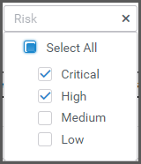You can filter records based on risk as shown in the figure:

1. Click on the Risk field. List of risk types appears.
2. Click to select the risk type to filter records. You can select multiple risk types to filter.
3. To select all the types, click Select All.
4. Click Apply. Records matching the selected risk type appears.

### Due Date

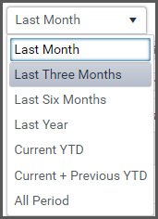You can filter records based on a selected Due Date as shown in the figure:

1. Click on the Due Date field. List of predefined duration appears.
2. Click to select the duration to filter records.
3. To select all time due date records, click All Period.
4. Click Apply. Records matching due dates as the selected duration appears.
5. You can also filter records with selected due dates manually by selecting the Start Date and End Date.

### Document Status

The compliance records are classified as follows:

* Document Mandatory: Attaching document is mandatory to perform the compliance.
* Document Not Mandatory: Attaching document is not mandatory to perform the compliance.

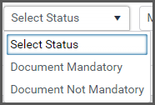You can filter compliance records based on document status as shown in the figure:

1. Click on the Select Status field.
2. Click to select the document status to filter records.
3. Click Apply. Compliance records matching the selected document status appears. For example, if you select Document Mandatory status, then all compliances that requires document attached mandatorily appears.

### Mitigation Plan

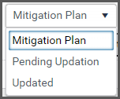For Overdue compliances, the performer can update the mitigation plan. In addition, the reviewer can view the mitigation plan updated by the performer.  
 You can filter compliances based on the selected mitigation plan status: Updated / Pending Updation as shown in the figure:

1. Click Mitigation Plan field and then select Updated / Pending Updation. Compliances with selected mitigation plan status appears.

### View Updated Mitigation Plan

1. 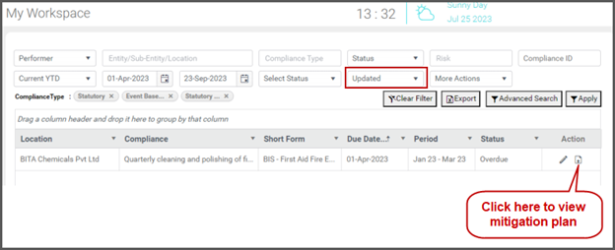On the My Workspace screen, click Mitigation Plan field and then select Updated. Compliances with mitigation plan already updated appears as shown in the figure:
2. In the Action column, clickcontents/assets/images/image263.png to view the mitigation plan.

### Update Mitigation Plan

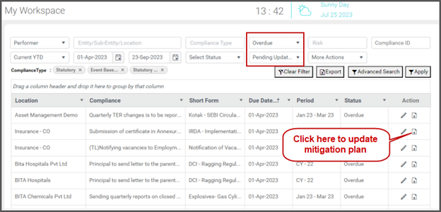The performer can update the mitigation plan by specifying reason for overdue and specifying a date for closing the compliance.

1. On the My Workspace screen, click Mitigation Plan field and then select Pending Updation. Compliances with mitigation plan pending updation appears as shown in the figure:
2. In the Action column, clickcontents/assets/images/image266.png to update mitigation plan. The Compliance Mitigation Plan screen appears as shown in the figure: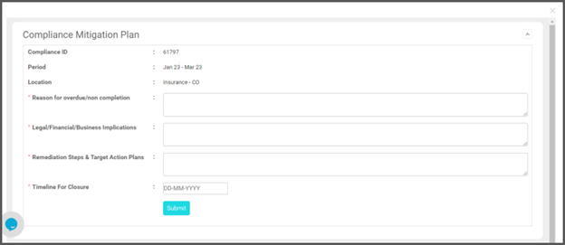
3. In the Reason for overdue /non completion field, type reason for overdue.
4. In the Legal / Financial / Business Implications field, type related implications if any.
5. In the Remediation Steps & Target Action Plans field, type remedy and action plan if any.
6. In the Timeline For Closure field, select a date to close the compliances.
7. Click Submit.

### Grouping Compliances Based on Selected Columns

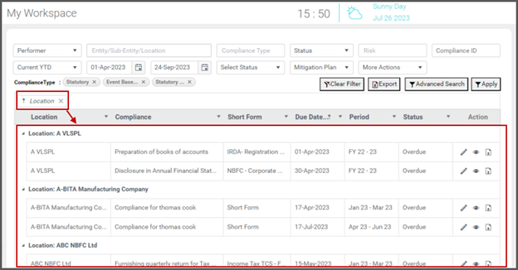You can group records based on a column or multiple column. Drag a column and drop it as shown in the figure:

Drag and drop more columns to further group the records.

## Advanced Search

My Workspace enables the user to use advanced search to fetch compliances based on the following:

* Act: Enables find compliances based on a selected Act.
* Department: Enables find compliances based on a selected department.
* Financial Year: Enables find compliances based on the selected financial year.
* User: Find compliances based on the user the compliance is assigned.

To use the advanced search, follow these steps:

1. On the My Workspace screen, click Advanced Search as shown in the figure:

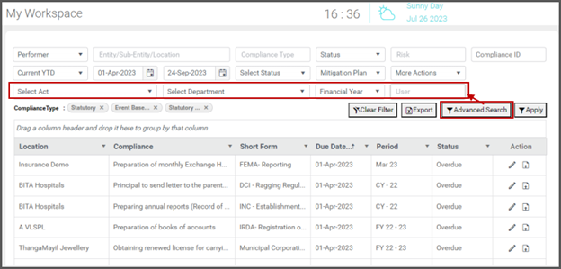

1. You can see the advanced search option appear as shown in the figure:

contents/assets/images/image292.png

1. Use one or more of the above options to search compliances.

## Adding or Removing Columns to the Grid

You can add or remove a column to the My Workspace grid. To do so, follow these steps:

1. On the My Workspace, click on a column header and then click Columns. The list of columns appears as shown in the figure:

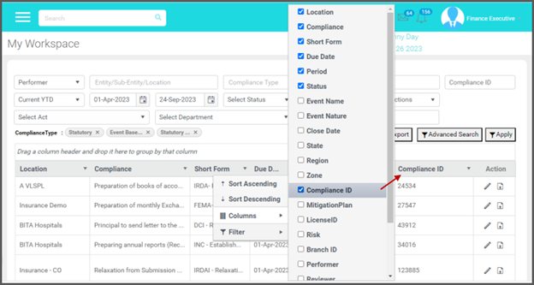

1. Click to select a column to add to the grid as shown in the above figure. For example, click Compliance ID. The column is added to the grid.
2. Click to deselect a column in the list to remove from the grid.

## Exporting Compliance Details

My Workspace enables you to export compliance details. To do so, follow these steps:

1. On the My Workspace screen, click Export as shown in the figure:

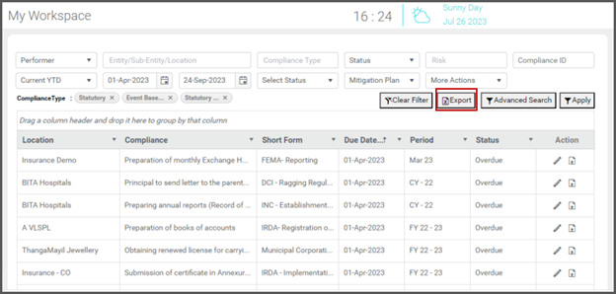

1. The list of compliances in the workspace are exported to the local storage.
2. Open the downloaded Excel file. The exported Excel file displays list of compliances as shown in the figure:

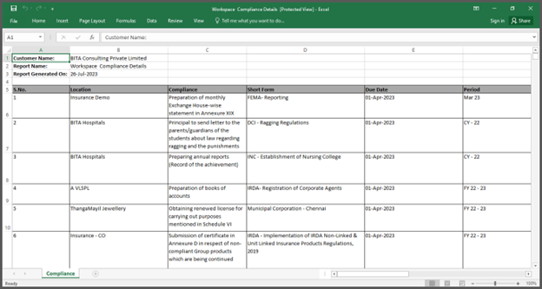

## Sort Records in Ascending or Descending Order

My Workspace enables you to sort records in ascending or descending order based on a selected column.  
 To sort the records, follow these steps:

1. On the My Workspace screen, click on a column to sort the records in ascending order based on that column.
2. Click again on that column to sort the records in descending order.
3. Click again to clear ascending /descending sorting.
4. Alternatively, you can click on the dropdown that appears on the column header and then click Sort Ascending / Sort Descending as shown in the figure:

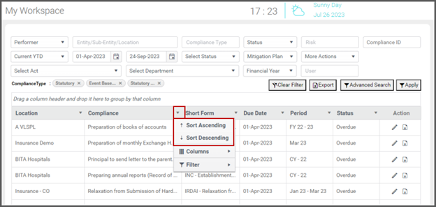

## More Actions

The More Actions section helps you to do the following:

* Update Penalty
* Revise Compliance
* Reassign Performer

### Revise Compliance

The performer/reviewer can revise a closed compliance when there is a change in documents/information etc. The performer/ reviewer can revise a compliance multiple time.

To revise a compliance, follow these steps:

1. On the My Workspace screen, click the More Actions field and then select Revise Compliance.
2. The Revise Compliance screen appears as shown in the figure:

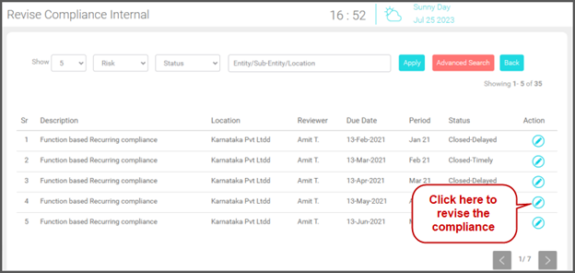

1. You can see list of closed compliances.
2. Click on thecontents/assets/images/image277.png icon of a compliance to revise. The record opens as shown in the figure:

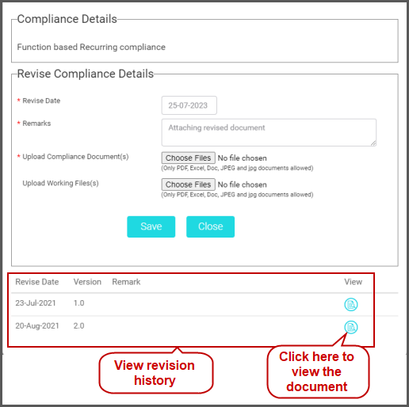

1. Under Revise Compliance Details, fill in the details.
2. In the Revise Date field, click and select the date of revision.
3. In the Remarks field, type your remarks.
4. In the Upload Compliance Document(s) field, click Choose Files and upload the latest file. You can upload multiple documents.
5. In the Upload Working File(s) field, click Choose Files and upload files. You can upload multiple working files.
6. You can also view version history of the attached documents as shown in the above figure.
7. Clickcontents/assets/images/image276.png to open the document version for view.
8. Click Save.

Now the compliance goes to the Reviewers queue and appears in Pending For Review status as shown in the figure:

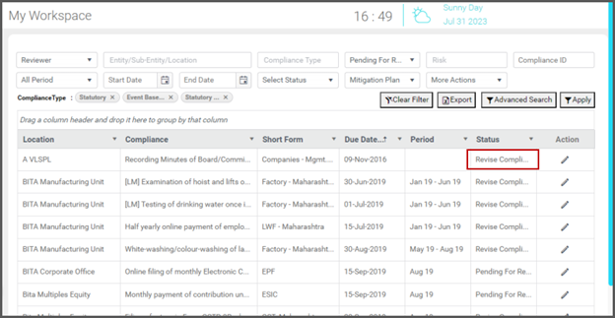

### Update Penalty

When a compliance is closed after due date, the performer may not know the penalty amount at that time. So, selects the Value not known at this moment option and close the compliance. Later, the performer can update penalty details. To do so, follow these steps:

1. On the My Workspace screen, click the More Actions field and then select Update Penalty as shown in the figure:

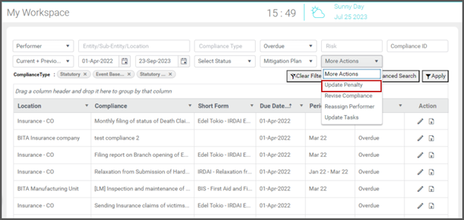

1. The Penalty Updation screen appears as shown in the figure:

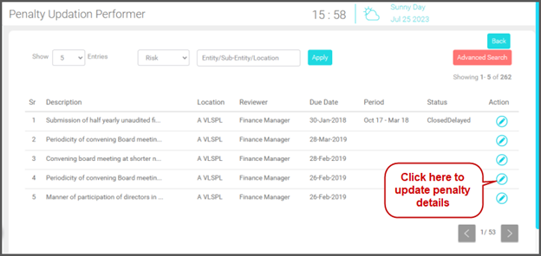

1. You can see list of compliances to update penalty.
2. Click on thecontents/assets/images/image272.png  icon of a compliance to update penalty. The compliance record opens with Penalty Information as shown in the figure:

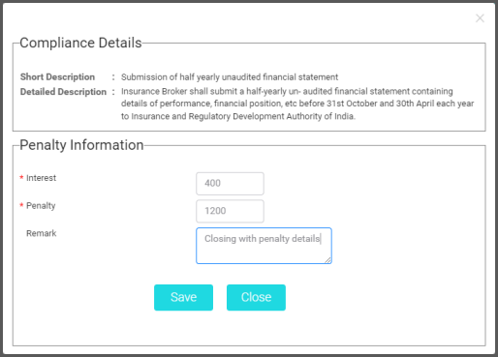

1. Under Compliance Details, you can see the compliance details.
2. Under Penalty Information, fill in the following fields:
   * In the Interest field, type the interest for the penalty.
   * In the Penalty field, type the penalty amount.
   * In the Remarks field, type remarks.
3. Click Save.

### Reassign Performer

If inappropriate compliances are assigned, the reviewer can reassign the compliances to a different user/performer. To do so, follow these steps:

1. Go to the My Workspace screen.
2. On the My Workspace screen, select Reviewer in the Performer / Reviewer field.
3. Click More Actions, select Reassign Performer and then click Apply as shown in the figure:

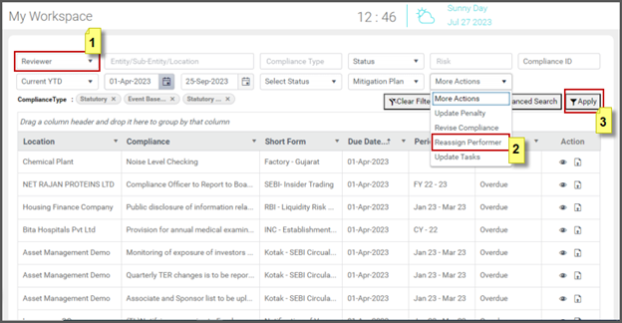

1. The screen appears as shown in the figure:

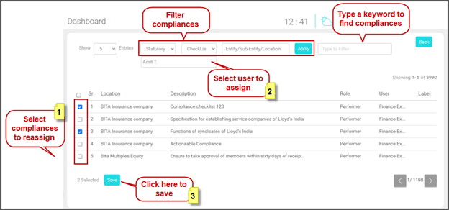

1. Filter compliances using Statutory/Internal, Type and Location fields.
2. You can also search compliances based on a keyword. Type a keyword from the compliance title/description to fetch compliances.
3. Click to select compliances to reassign.
4. In the Select User To Assign field, select a user to assign the selected compliances.
5. Click Save. A confirmation dialog appears asking for confirmation as shown in the figure:

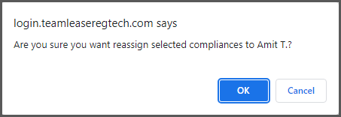

1. Click Ok.
2. The selected compliances are assigned to the selected user as shown in the figure:

